190905104
Parth Shukla
Lab 4

1)
// Write a program to find the inode number of an existing file in a directory. Take the input as a filename and print the inode number of the file.
#include <sys/types.h>
#include <sys/stat.h>
#include <unistd.h>
#include <stdio.h>
#include <stdlib.h>

int main (int argc, char *argv[]){
struct stat sb;
int ret;

if (argc < 2) {
fprintf (stderr, "usage: %s <file>\n", argv[0]);
return 1;
}

ret = stat(argv[1], &sb);

if (ret){
perror("stat");
return 1;
}

printf("Inode number for %s is: %ld\n", argv[1], sb.st_ino);

return 0;
}

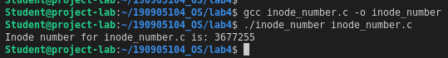

2)
// Write a program to print out the complete stat structure of a file.

#include <sys/types.h>
#include <sys/stat.h>
#include <unistd.h>
#include <stdio.h>
#include <stdlib.h>
#include <string.h>
#include <dirent.h>
#include <time.h>

char* todate(char* str, time_t val){
strftime(str, 36, "%d.%m.%Y %H:%M:%S", localtime(&val));
return str;
}

int main(int argc, char* argv[]){
struct stat sb;
int ret;
char date[100];
if(argc < 2){
fprintf (stderr, "usage: %s <file>\n", argv[0]);
return 1;
}

ret = stat(argv[1], &sb);

if (ret){
perror("stat");
return 1;
}

printf("ID of device: %ld\n", sb.st_dev);
printf("Inode number: %ld\n", sb.st_ino);
printf("File mode - %hu\n", sb.st_mode);
printf("Number of hard links - %ld\n", sb.st_nlink);
printf("User ID - %d\n", sb.st_uid);
printf("Group owner - %d\n", sb.st_gid);
printf("File size - %ld\n", sb.st_size);
printf("Blocksize - %ld\n", sb.st_blksize);
printf("Number of Blocks - %ld\n", sb.st_blocks);
printf("Last access time - %s\n", todate(date,sb.st_atime));
printf("Last modification time - %s\n", todate(date,sb.st_mtime));
printf("Last change time - %s\n", todate(date,sb.st_ctime));

DIR * dp;

struct dirent * entry;
struct stat statbuf;

if((dp = opendir(".")) == NULL)
{
printf("Cannot open directory \n");
return 0;
}

chdir(".");

while((entry = readdir(dp)) != NULL){
lstat(entry->d_name,&statbuf);

if(!S_ISDIR(statbuf.st_mode)){
if(strcmp(entry->d_name,argv[1])==0){
printf("Permissions\t");
printf((S_ISDIR(statbuf.st_mode)) ? "d" : "-");
printf((statbuf.st_mode & S_IRUSR) ? "r" : "-");
printf((statbuf.st_mode & S_IWUSR) ? "w" : "-");
printf((statbuf.st_mode & S_IXUSR) ? "x" : "-");
printf((statbuf.st_mode & S_IRGRP) ? "r" : "-");
printf((statbuf.st_mode & S_IWGRP) ? "w" : "-");
printf((statbuf.st_mode & S_IXGRP) ? "x" : "-");
printf((statbuf.st_mode & S_IROTH) ? "r" : "-");
printf((statbuf.st_mode & S_IWOTH) ? "w" : "-");
printf((statbuf.st_mode & S_IXOTH) ? "x" : "-");
printf("\n");
}
}
}
}

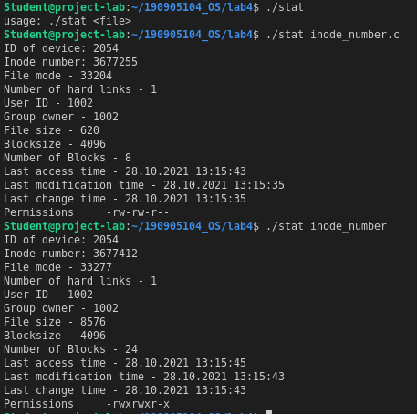

3)

// Write a program to create a new hard link to an existing file and unlink the same. Accept the old path as input and print the newpath.

#include <sys/types.h>
#include <sys/stat.h>
#include <unistd.h>
#include <stdio.h>
#include <stdlib.h>
#include <string.h>
#include <dirent.h>
#include <time.h>

int main(int argc, char* argv[]){
struct stat sb;
int ret;

if (argc < 2) {
fprintf (stderr, "usage: %s <file>\n", argv[0]);
return 1;
}

ret = stat(argv[1], &sb);

if (ret){
perror("stat");
return 1;
}

printf("Number of hard links: %ld\n", sb.st_nlink);

char* new_path = "q2_stat.c";

int ret2 = link(argv[1], new_path);

printf("Linking %s to %s\n", argv[1], new_path);

struct stat intermediate;
int ret3 = stat(argv[1],&intermediate);
printf("Number of hard links: %ld\n", intermediate.st_nlink);

printf("Unlinking\n");
int ret4 = unlink(argv[1]);

struct stat final;
int ret5 = stat(new_path, &final);
printf("Number of hard links: %ld\n", final.st_nlink);

return 0;

}

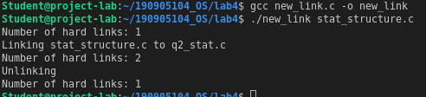
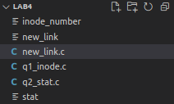
Directory after execution. stat_structure.c has been linked to q2_stat.c and stat_structure.c has been unlinked and hence can not be seen.

4)
// Write a program to create a new soft link to an existing file and unlink the same. Accept the old path as input and print the newpath.

#include <sys/types.h>
#include <sys/stat.h>
#include <unistd.h>
#include <stdio.h>
#include <stdlib.h>
#include <string.h>
#include <dirent.h>
#include <time.h>

int main(int argc, char* argv[]){
struct stat sb;
int ret;

if (argc < 2) {
fprintf (stderr, "usage: %s <file>\n", argv[0]);
return 1;
}

ret = stat(argv[1], &sb);

if (ret){
perror("stat");
return 1;
}

char* new_path = "inode_number.c";
system("ls");
printf("Linking %s to %s\n", argv[1], new_path);

int ret2 = symlink(argv[1], new_path);

struct stat intermediate;
int ret3 = stat(argv[1],&intermediate);
system("ls");

printf("Unlinking\n");
int ret4 = unlink(argv[1]);

struct stat final;
int ret5 = stat(new_path, &final);
system("ls");
}

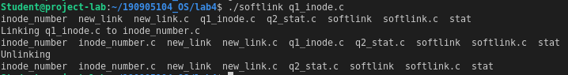
Directory after execution. q1_inode.c has been softlinked to inode_number.c and then q1_inode.c was deleted.

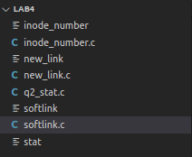

Additional

1)
// Inode number of all files in directory

#include <sys/types.h>
#include <sys/stat.h>
#include <unistd.h>
#include <stdio.h>
#include <stdlib.h>
#include <dirent.h>

int main(int argc, char* argv[]){

struct stat sb;
int ret;

if (argc < 2) {
fprintf (stderr, "usage: %s <file>\n", argv[0]);
return 1;
}

DIR * dp;

struct dirent * entry;
struct stat statbuf;

if((dp = opendir(argv[1])) == NULL)
{
printf("Cannot open directory \n");
return 0;
}

chdir(argv[1]);

while((entry = readdir(dp)) != NULL){
lstat(entry->d_name,&statbuf);

if(!S_ISDIR(statbuf.st_mode)){
printf("Inode number for %s: %ld\n", entry->d_name, statbuf.st_ino);
}
}
return 0;
}
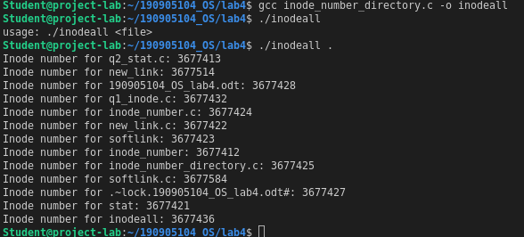

2) Stat structure for directory

// Write a program to print out the complete stat structure of a file.

#include <sys/types.h>
#include <sys/stat.h>
#include <unistd.h>
#include <stdio.h>
#include <stdlib.h>
#include <string.h>
#include <dirent.h>
#include <time.h>
#include <string.h>

char* todate(char* str, time_t val){
strftime(str, 36, "%d.%m.%Y %H:%M:%S", localtime(&val));
return str;
}

int main(int argc, char* argv[]){
struct stat sb;
int ret;

if (argc < 2) {
fprintf (stderr, "usage: %s <file>\n", argv[0]);
return 1;
}

DIR * dp;

struct dirent * entry;
struct stat statbuf;

if((dp = opendir(argv[1])) == NULL)
{
printf("Cannot open directory \n");
return 0;
}

chdir(argv[1]);
char date[100];

while((entry = readdir(dp)) != NULL){
if(strcmp(entry->d_name, ".")==0 || strcmp(entry->d_name, "..")==0) continue;

ret = stat(entry->d_name,&sb);

printf("Stat for %s\n", entry->d_name);

printf("\tID of device: %ld\n", sb.st_dev);
printf("\tInode number: %ld\n", sb.st_ino);
printf("\tFile mode - %hu\n", sb.st_mode);
printf("\tNumber of hard links - %ld\n", sb.st_nlink);
printf("\tUser ID - %d\n", sb.st_uid);
printf("\tGroup owner - %d\n", sb.st_gid);
printf("\tFile size - %ld\n", sb.st_size);
printf("\tBlocksize - %ld\n", sb.st_blksize);
printf("\tNumber of Blocks - %ld\n", sb.st_blocks);
printf("\tLast access time - %s\n", todate(date,sb.st_atime));
printf("\tLast modification time - %s\n", todate(date,sb.st_mtime));
printf("\tLast modification time - %s\n", todate(date,sb.st_mtime));
printf("\tLast change time - %s\n", todate(date,sb.st_ctime));

printf("\tPermissions\t");
printf((S_ISDIR(sb.st_mode)) ? "d" : "-");
printf((sb.st_mode & S_IRUSR) ? "r" : "-");
printf((sb.st_mode & S_IWUSR) ? "w" : "-");
printf((sb.st_mode & S_IXUSR) ? "x" : "-");
printf((sb.st_mode & S_IRGRP) ? "r" : "-");
printf((sb.st_mode & S_IWGRP) ? "w" : "-");
printf((sb.st_mode & S_IXGRP) ? "x" : "-");
printf((sb.st_mode & S_IROTH) ? "r" : "-");
printf((sb.st_mode & S_IWOTH) ? "w" : "-");
printf((sb.st_mode & S_IXOTH) ? "x" : "-");
printf("\n");
}
